Assessment Task 1: Critical Literature Review
Course code and name: | BUSM3115 Ethics and Governance
Assessment task: | Assignment 1 – Critical Reflection on Course Literature
Length: | 1200 words maximum (+/- 50 words)  (exclusive of references, appendices etc.)
Assessment task details
Read the following papers which offer different insights about ethical decision making and the various influences on them.

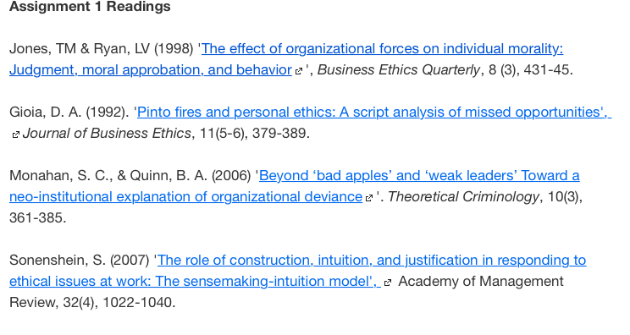

Compare and contrast these readings (Gioia 1992; Jones & Ryan 1998; Monahan & Quinn 2006; Sonenshein 2007) and produce a 1200 word critical reflection on the four articles about what ethical decision making is, and the factors that influence ethical decision making in organisations.

In this critical reflection you should provide a reasoned explanation for choosing the perspective(s) that you believe best explain ethical decision making in organisations.
Please read the Ethics & Governance - Assessment Guide for details on writing and referencing requirements for this assessment.

Assessment criteria
Criteria | Weight | HD | D | C | P | U
Key issues relating to the question have been developed | 30% | Responds originally, clearly and directly to the question.  The work shows good evidence of original insight.  Evidence of the selection of high quality information/references.  The work demonstrates a high level of understanding and curiosity in analysing the question and clearly addresses the task requirements. | Responds clearly and directly to the question.  The work demonstrates some evidence of original insight.  Evidence of the selection of relevant information/references appropriate to the task.  The work demonstrates comprehensive understanding of the task and addresses task requirements. | Responds directly to the question.  The work shows some insight.  Evidence of selection of information for the task, but it is not always relevant or fully discussed.  The work demonstrates an understanding of the task and addresses task requirements. | Considered attempt to respond to the question.  Limited expression and response to the task.  Very limited selection of information/ references.  The work demonstrates some understanding of the task but does not address all task requirements. | Does not respond, or only partially responds to the question.  Very limited expression of ideas and response to the task.  Limited or no selection of information/ references.  Inadequate understanding of the task; has not sufficiently addressed all task requirements.
Logical and convincing discussion - Original and clear argument | 40% | Material is deployed in a disciplined way and demonstrates a sophisticated comprehension of key issues of debate.  Advanced ability to critically review, analyse, synthesise and apply theoretical and technical body knowledge in a broad and creative way to a range of areas and diverse contexts.  Highly effective use of a range of literature to build a strong argument. | Competent interpretation of several sources of information/data & synthesis to integrate knowledge into standard formats.  Demonstrates a high level of critical analysis and synthesis through use of theory and selection, interpretation and integration of multiple sources of information/data.  Strong use of the literature/course readings to build an argument. | Demonstrates critical analysis and synthesis through the selection and integration of a range of information/ data.  Competent use of theory and generally credible evidence to support arguments and demonstrate understanding.  Use of conceptual skills to express ideas and offer some perspectives.  Evidence of the use of literature/ course readings to build an argument. | Adequate response to the task. Limited analysis and synthesis through the selection sources of information/data.  Able to use theory and evidence to demonstrate limited understanding.  Able to use some conceptual skills to express ideas and offer limited perspectives.  Limited or no evidence of use of literature/course readings to build an argument. | Inadequate response to the task.  Unsatisfactory attempts at analysis and limited synthesis through the selection sources of information/data.  Unable to use theory and evidence to demonstrate understanding.  Unsatisfactory attempt to use some conceptual skills to express ideas and offer limited perspectives.  Inability to demonstrate original justification of solution.  Inability to connect the literature/course readings to build an argument. Over-reliance on quotes.
Clear and comprehensive written style (spelling, grammar, syntax etc.) | 20% | Highly developed and appropriate structure designed to effectively present argument.  Meaning is communicated clearly and effectively through consistent and sophisticated use of academic style, unambiguous language and correct and appropriate grammar, vocabulary, punctuation and spelling. | Clear and appropriate structure designed to present argument.  Mostly clear, well-integrated evidence from appropriate sources using accurate paraphrase and summary.  Meaning is communicated clearly through consistent use of academic style, unambiguous language and correct and appropriate grammar, vocabulary, punctuation and spelling. | Features a clear structure to present the argument.  Generally integrates relevant theory from a number of mostly appropriate sources using adequate paraphrasing.  Meaning is made clear through mostly correct and appropriate formal academic style, grammar, vocabulary, punctuation and spelling. | Features a discernible structure.  May include some irrelevant information.  Integrates relevant theory from a number of sources using adequate paraphrasing but with occasional irrelevant information or inadequate integration.  Meaning is generally made clear through adequate and appropriate formal academic style, grammar, vocabulary, punctuation and spelling; some lapses causing lack of clarity. | Lack of clear structure.  Sentences and are inadequately developed with poor coherence of ideas and irrelevant information.  Use and integration of sources is inadequate with frequently incorrect paraphrasing.  Meaning is impeded through frequent use of informal language and errors in grammar, vocabulary, punctuation and spelling.
Appropriate Harvard style referencing (in text and list of references) | 10% | References consistently conform to the appropriate conventions.  Excellent reference list in terms of quantity and quality.  Effective citation in text, both in terms of style and content. | References mostly conform to the appropriate conventions.  Very good reference list in terms of quantity and/or quality.  Appropriate citation in text, both in terms of style and content. | References generally conform to the appropriate conventions.  Good reference list in terms of quantity and/or quality.  Adequate citation in text, both in terms of style and content. | References do not always conform to the appropriate conventions.  Adequate reference list in terms of quantity and/or quality.  Adequate citation in text, in terms of style and/or content; some scope for improvement. | References do not conform to the appropriate conventions.  Inadequate reference list in terms of quantity and or quality.  Inadequate and/or incorrect citation in text, both in terms of style and content.

